**ECE 20100 – Fall 2016**

**Final Exam**

**December 12, 2016**

**Sections (include on scantron)**

Hosseini (9:30) – 0002 Peleato-Inarrea (3:30) – 0004 Michelusi (1:30) – 0005

Qi (10:30) – 0011 Cui (8:30) – 0012

Peroulis (11:30) – 0013 Kildishev (1:30) – 0014

Name ____________________________ PUID____________

***Instructions***

1. DO NOT START UNTIL TOLD TO DO SO.
2. Write your name, section, professor, and student ID# on your **Scantron** sheet. We may check PUIDs.
3. This is a CLOSED BOOKS and CLOSED NOTES exam.
4. The use of a TI-30X IIS calculator is allowed, but not necessary.
5. If extra paper is needed, use the back of test pages.
6. Cheating will not be tolerated and will be dealt with according to the policy in your section. In particular, **continuing to write after the exam time is up is regarded as cheating**.
7. If you cannot solve a question, be sure to look at the other ones, and come back to it if time permits.

**By signing the scantron sheet, you affirm you have not received or provided assistance on this exam.**

**Question 1**

A resistor of unknown resistance has a 4 A current passing through it, as shown. The power absorbed by the resistor is 12 W. Find the voltage (in V) across the resistor for these conditions.

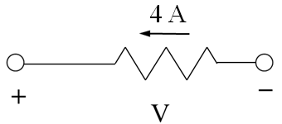

1. 1 V
2. 2 V
3. 3 V
4. 4 V
5. -1 V
6. -2 V
7. -3 V
8. -4 V
9. None of the above

**Question 2**

For the circuit below, find the voltage, *VBC* (in V):

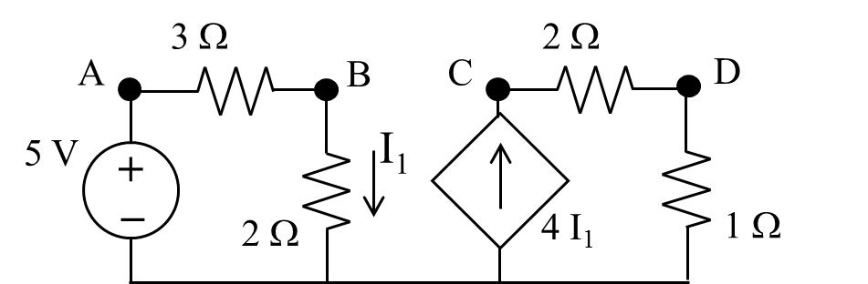

1. 2
2. 8
3. 10
4. 12
5. 20
6. -2
7. -8
8. -10
9. -12
10. None of the above

**Question 3**

Find the node voltage, *VA* (in V).

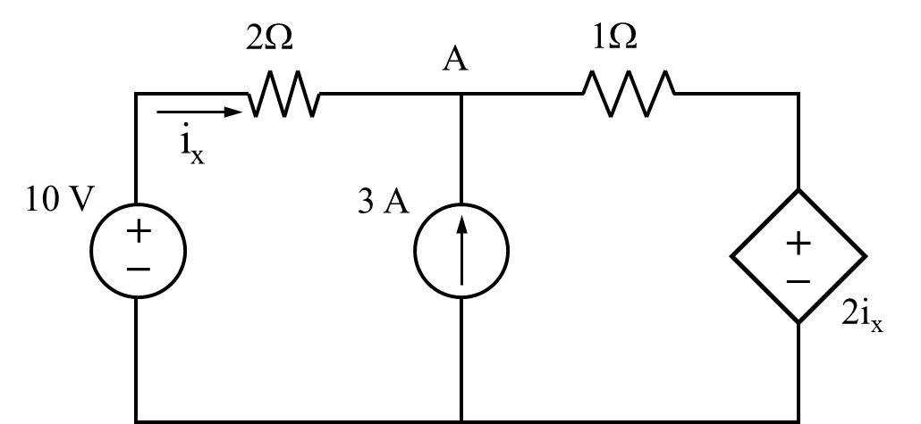

1. 1.2
2. 2.4
3. 3.6
4. 4.0
5. 5.0
6. 6.8
7. 7.2
8. 8.0
9. None of the above

**Question 4**

Using source transformations or any other analysis technique, find the value of the Norton Equivalent current source (in A) for the circuit below.

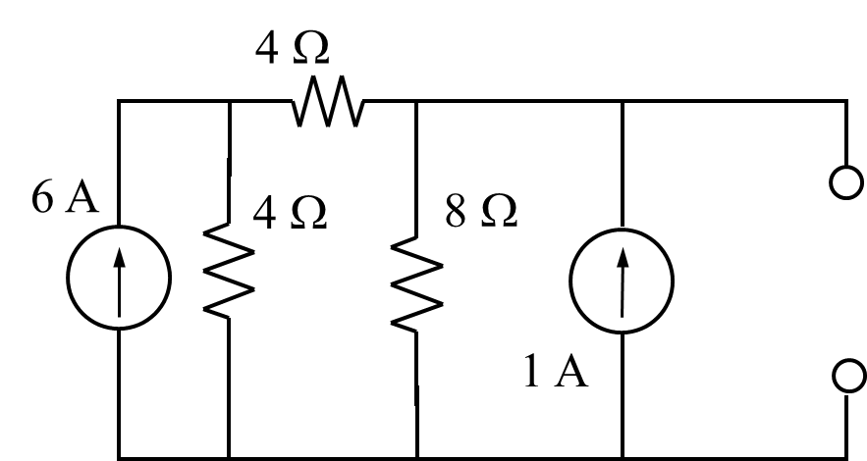

1. 1
2. 2
3. 3
4. 4
5. 5
6. 6
7. 7
8. 8
9. 9
10. None of the above

**Question 5**

The linear circuit below consists of resistors and sources only. Experiments were performed to evaluate circuit parameters. Two current/voltage relationships were found to be:

*v* = 10 V, *iL* = 0 A

*v* = -10 V, *iL* = 2 A

Find the value of the Thevenin equivalent resistance, *RTH*, for the linear circuit (in ).

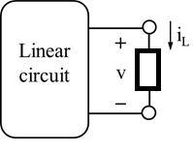

1. 10
2. 2
3. 30
4. 4
5. 5
6. 20
7. 40
8. 8
9. None of the above

**Question 6**

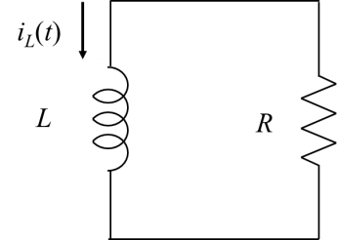

The current through an inductor when connected to a resistor, *R*, in a zero-input (undriven), first-order RL circuit is:

*iL(t)* = 2 e-3t A t ≥ 0

The instantaneous stored energy in the inductor at t = 0 is known to be 400 mJ. Find the value of the resistance to which the inductor is connected (in ).

1. 0.1
2. 0.2
3. 0.3
4. 0.4
5. 0.5
6. 0.6
7. 0.7
8. 0.8
9. 0.9
10. none of the above

**Question 7**

The capacitor voltage in a driven, first-order RC circuit with a constant voltage source is:

*vC(t)* = 5 - 8 e-4t V t ≥ 0

Find the value of *vC(0****-****)* (in V).

1. 1
2. 2
3. 3
4. 4
5. 5
6. -1
7. -2
8. -3
9. There is insufficient information
10. none of the above

**Question 8**

In the circuit below, the switch has been closed for a long time. At *t* = 0 sec, the switch opens. Assuming a solution for the capacitor voltage of the form,

*vC(t)* = A cos(t) + B sin(t) V

find the closest value for the constant B.

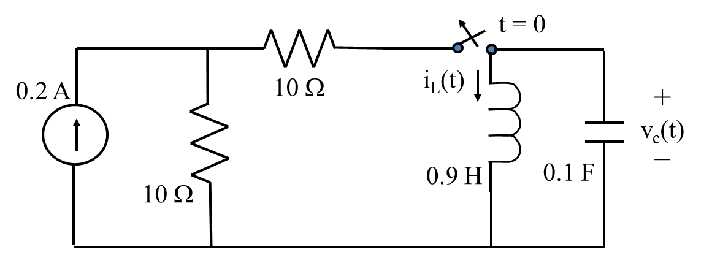

(1) -0.1

(2) -0.2

(3) -0.3

(4) -0.4

(5) -0.5

(6) -0.6

(7) -0.7

(8) -0.8

(9) None of the above

**Question 9**

The switch in the circuit below has been opened for a long time. It closes at t = 0 s. Find at *t* = 0+ (in V/s).



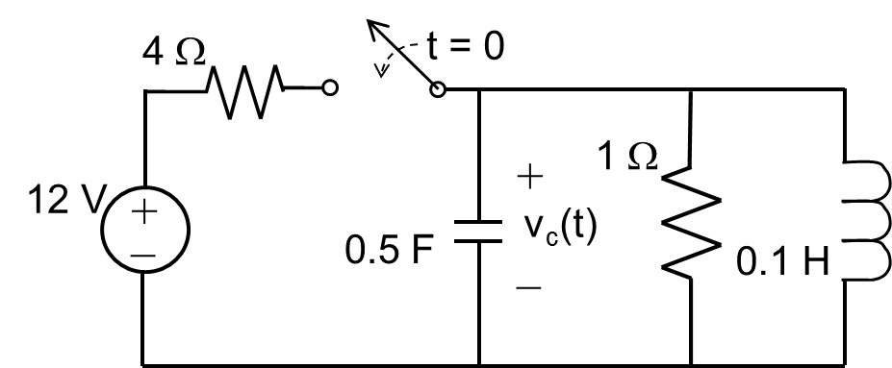

1. 1
2. 2
3. 3
4. 4
5. 5
6. 6
7. 7
8. 8
9. None of the above

**Question 10**

Find the characteristic equation for the circuit below for *t* > 0.

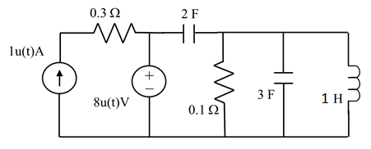

(1) s2 + 0.1s + 0.2 = 0

(2) s2 + 4s + 0.2 = 0

(3) s2 + 8.33s + 0.833 = 0

(4) s2 + 2s + 0.2 = 0

(5) s2 + 16.67s + 0.833 = 0

(6) s2 + 0.2s + 0.833 = 0

(7) s2 + 5s + 1 = 0

(8) None of the above

**Question 11**

In the circuit below, find the power delivered by the current source (in mW).

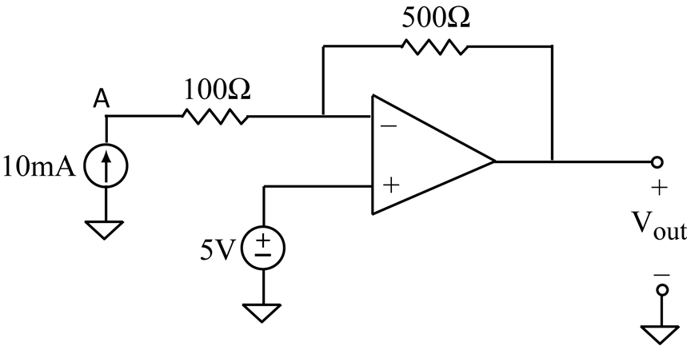

1. 10
2. 20
3. 30
4. 40
5. 50
6. 60
7. 70
8. 80
9. None of the above

**Question 12**

Given the phasor currents shown below, determine the phasor current (in A) through the capacitor.

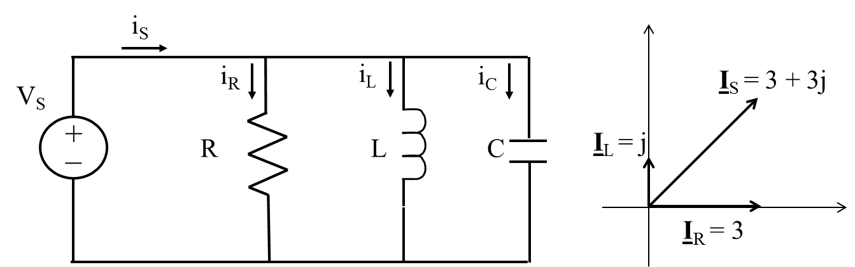

(1) j

(2) 2j

(3) 3j

(4) 4j

(5) 5j

(6) 3 + 4j

(7) 3 + 2j

(8) 3 + 5j

(9) None of the above

**Question 13**

The input impedance in the circuit below is 1 ∠ -60o . Find the instantaneous power generated by the source (in W).

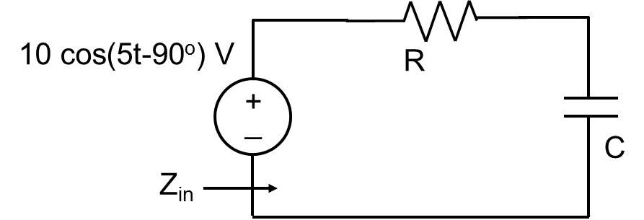

(1) 100 + 50 cos(10t - 60°)

(2) 100 + 25 cos(10t - 120°)

(3) 25 + 25 cos(10t - 60°)

(4) 25 + 50 cos(10t - 120°)

(5) 50 + 25 cos(10t - 60°)

(6) 50 + 50 cos(10t - 60°)

(7) 75 + 50 cos(10t - 120°)

(8) 75 + 25 cos(10t - 60°)

(9) 100

(10) None of the above

**Question 14**

Find the average power (in W) absorbed by the 6  resistor in the circuit shown below.

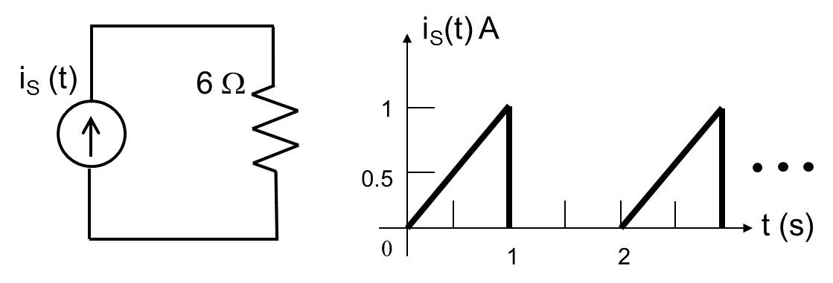

(1) 1

(2) 2

(3) 3

(4) 0.5

(5) 0.33

(6) 6

(7) 12

(8) 1.5

(9) None of the above

**Question 15**

Find the effective (rms) voltage for the waveform shown below (in V).

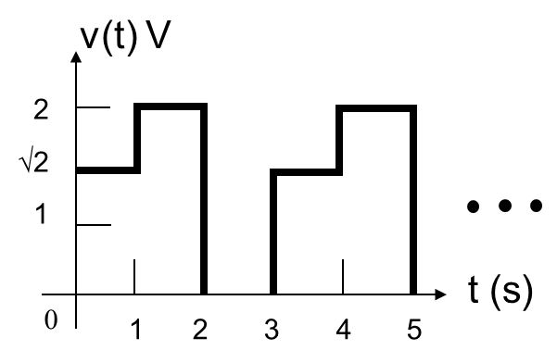

(1) 1

(2) 2

(3) √3

(4) 4

(5) √2

(6) 6

(7) 2√2

(8) (2/3)√3

(9) None of the above

**Question 16**

Find the reactive power (in VAR) for the capacitor (rms) voltage given a source voltage of   
v(t) = 50√2 sin(10 t) V.

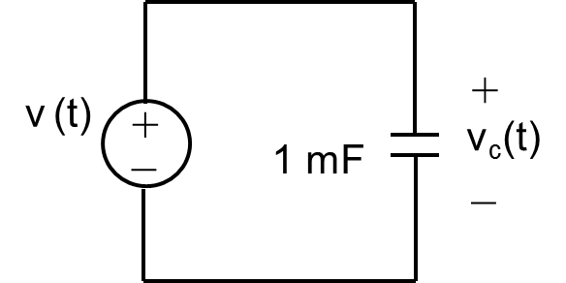

(1) 25

(2) -25

(3) 50

(4) -50

(5) 100

(6) -100

(7) 50√2

(8) -50√2

(9) None of the above

**Information for next 2 problems**

A voltage source supplies power to four machines. The complex power absorbed by each machine is:

**S1** = 75 + 60 j **S2** = 110 + 80 j

**S3** = 125 + 100 j **S4** = 90 + 60 j

**Question 17**

Find the apparent power (in VA) delivered by the source (i.e. │SS│).

(1) 100

(2) 200

(3) 300

(4) 400

(5) 500

(6) 600

(7) 700

(8) 800

(9) None of the above

**Question 18**

Find the power factor for the source.

(1) 0.70 leading

(2) 0.75 leading

(3) 0.80 leading

(4) 0.85 leading

(5) 0.70 lagging

(6) 0.75 lagging

(7) 0.80 lagging

(8) 0.85 lagging

(9) None of the above

**Question 19**

In the circuit below, the complex power absorbed by loads ‘1’ and ‘2’ are,

**S**1 = 12 kW – j16 kVAR

**S**2 = 8 kW + j 6 kVAR

If a capacitor *or* an inductor is added to the circuit (as shown in dashed line), what is proper selection below that gives a power factor of 0.95 *leading*:

100√2 cos(5t) V

# C or L

+

_

1

2

(1) Capacitor: C = 0.116 F

(2) Capacitor: C = 0.584 F

(3) Capacitor: C = 1.713 F

(4) Capacitor: C = 2.919 F

(5) Inductor: L = 0.116 H

(6) Inductor: L = 0.584 H

(7) Inductor: L = 1.713 H

(8) Inductor: L = 2.919 H

(9) None of the above

**Question 20**

In the circuit below, choose the load impedance for maximum power transfer to the load resistor Rload.

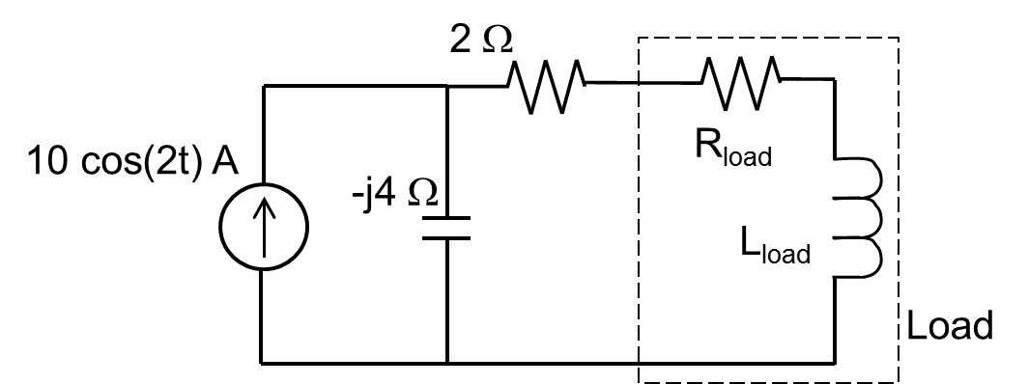

(1) 1 + j

(2) 1 – j

(3) 1 + 2j

(4) 1 – 2j

(5) 2 + 4j

(6) 2 – 4j

(7) 2 + 2j

(8) 2 – 2j

(9) None of the above

**Potentially Useful Formulas**



First order circuit: ,  = L/R or  = RC

Series RLC: 

Parallel RLC: 







, where 











$$\cos\left(A\right)cos\left(B\right)=\frac{1}{2}\left[\cos\left(A-B\right)+\cos\left(A+B\right)\right] \\ \sin\left(A\right)sin\left(B\right)=\frac{1}{2}\left[\cos\left(A-B\right)-\cos\left(A+B\right)\right] \\ \sin\left(A\right)cos\left(B\right)=\frac{1}{2}\left[\sin\left(A-B\right)+\sin\left(A+B\right)\right]$$

**Solution Key:**

1. (7)
2. (8)
3. (7)
4. (4)
5. (1)
6. (6)
7. (8)
8. (3)
9. (6)
10. (4)
11. (6)
12. (2)
13. (4)
14. (1)
15. (5)
16. (2)
17. (5)
18. (7)
19. (6)
20. (5)